**Assignment Name**: **Lab10:** (**Functions (V2))**

**Due date:** **11/16/2022, by 11:00 am.**

**Grade for assignment: 20** points

**Purpose:** Obtain experience in using Functions and realizing the importance of security in software development. Assignment accomplishes course learning objective “using basic control structures”. Assignment also provides preparation for COSC236 course, and enhances skills needed in Information Technology (IT) and Computer Science industries.

**Skills:** Purpose of assignment is to help you practice the following skills.

-Ability to use Void Functions

-Ability to use Value-Returning Functions

**Knowledge:** Become familiar with when Void and Value-Returning Functions should be used.

**\*\*\*\*\*\*\*\*\*\*\*\*\*\*\*\*\*\*\*\*\*\*\*\*\*\*\*\*\*\*\*\*\*\*\*\*\*\*\*\*\*\*\*\*\*\*\*\*\*\*\*\*\*\*\*\*\*\*\*\*\*\*\*\*\*\*\*\*\*\*\*\*\*\*\*\***

**Place your Name(s) below:**

**Pairs work:** Please work in pairs. **One student in team should submit work**. Put **your first and last name on the assignment** and **your partner’s first and last name on the** assignment

**Note(s):**

1. All programs should be completed within the Visual Studio Code environment. There are guides in blackboard to start you off with Visual Studio Code.

**Partner 1: Name Blessing Abumere**

**role (did the typing or read and review) _____________________________**

**Partner 2: Name ______________________________________________**

**role (did the typing or read and review)______________________________**

**Please note if one partner did not work on all problems.**

**Submission instructions:** All submissions will be done using blackboard. **Answers are to be submitted in a Microsoft word document.**

**Task**:

**Examples:** Refer to your notes from class, the Functions (Part1) PowerPoint, Functions (Part2) PowerPoint, in class exercises and any available videos (located in Blackboard).

**Part1 (20 points):**

1. Type in the following program. Add a comment at the top to include your names and the date.

// Value-returning example

#include <iostream>

using namespace std;

float Double(float number);

int main()

{

char ans;

float number;

float area;

float finalResult;

cout << " do you want to play today (y/n)" << endl;

cin >> ans;

while ((ans == 'Y' || ans == 'y'))

{

cout << "Enter a number" << endl;

cin >> number;

finalResult = Double(number);

cout << number << " Doubled is " << number << endl;

cout << " do you want to play today (y/n)" << endl;

cin >> ans;

}

return 0;

} // end of main function

//****function Double*****

float Double(float number)

{

float results;

results = number - 1;

return results;

}

-Compile and Run.

1. Correct the **value-returning function** to double, “number”
2. Correct the **main function** to print out the value that is returned from the Double function.
3. **SUBMIT your code, and sample of output (Below):**
4. /*
5. Blessing Abumere
6. COSC 175
7. 11/9/2022
8. */
9. // Value-returning example
10. #include <iostream>
11. using namespace std;
12. float Double(float number);
13. int main()
14. {
15. char  ans;
16. float number;
17. float area;
18. float finalResult;
19. cout << " do you want to play today (y/n)" << endl;
20. cin >> ans;
21. while ((ans == 'Y' || ans == 'y'))
22. {
23. cout << "Enter a number" << endl;
24. cin >> number;
25. finalResult = Double(number);
26. cout << number << " Doubled is " << finalResult << endl; //b)   Correct the main function to print out the value that is returned from the Double function
27. cout << " do you want to play today (y/n)" << endl;
28. cin >> ans;
29. }
30. return 0;
31. } // end of main function
32. //****function Double***** a)   Correct the value-returning function to double, “number”
33. float Double(float number)
34. {
35. float results;
36. results = number * 2;
37. return results;
38. }

**\*\*\*\*\*\*\*\*\*\*\*\*\*\*\*\*\*\*\*\*\*\*\*\*\*\*\*\*\*\*\*\*\*\*\*\*\*\*\*\*\*\*\*\*\*\*\*\*\*\*\*\*\*\*\*\*\*\*\*\*\*\*\*\*\*\*\*\*\*\*\*\*\*\*\*\*\***

**Criteria for Success**:

**a**) Be sure to submit your code and output above for each question; **Submission of Code and output is required**. (Note: use screen shots or copy and paste).

For example if the assignment was to write a program that displays “Hello World”

Your **code** would be as follows:

//Lab1 answer COSC175002

#include <iostream>

using namespace std;

int main()

{

cout << "Hello, world" << endl;

system("pause");

} // end of main

Your **output** would be as follows:

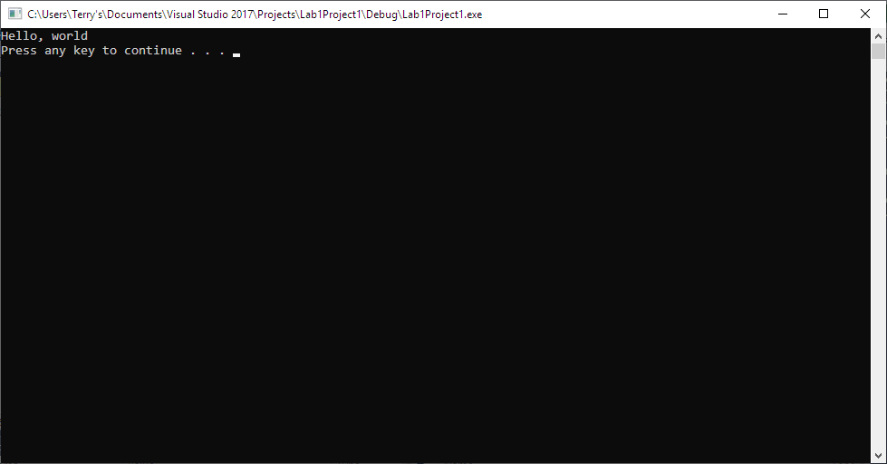

Note: To avoid additional point deductions; remember to submit both code and output.

>>>

**b)** Be sure to show completion of Security Injections by providing Screen shots of (or copy and paste) your Security Injection completion **Certificate** above**. Do not email me your certificate.**

**c) Late policy:** Late submissions will receive a zero grade. Get help during the week so that you can submit on time.